
web development:5020
Student Number: ST10526546

Author: Lesedi mulaudzi

Website Project Proposal: Immaculate Day Care
1. Organisation Overview
Organisation Name:
Immaculate Day Care
Brief History of the Organisation:
Immaculate Day Care is a community-based non-profit organisation that provides care and early childhood education for young children. The organisation also supports families by providing meals and a safe learning environment. Its activities include childcare, educational activities and feeding programmes.
For the purpose of this website project, the organisation will be presented as a community-focused day care centre that aims to support young children and their families through education, care and community support.
Mission Statement:
The mission of Immaculate Day Care is to provide young children with a safe, caring and supportive environment where they can receive early childhood education, care and access to basic support such as meals.
Vision Statement:
The vision of Immaculate Day Care is to create a positive environment where young children can learn, develop and receive the support they need while also strengthening support for families within the local community.
Target Audience:
The main target audience includes:
- Parents and guardians of young children.
- Families in the local community.
- People interested in volunteering.
- Individuals or organisations interested in making donations.
- Community members who want to learn more about the organisation.

2. Website Goals and Objectives
The main goal of the proposed website is to create an informative and user-friendly online presence for Immaculate Day Care.
Website Goals:
The website will aim to:
- Increase awareness of Immaculate Day Care and the services it provides.
- Provide parents and families with important information about the organisation.
- Make it easier for people to contact the organisation.
- Promote the organisation's childcare, educational and feeding programmes.
- Encourage community members to volunteer or provide donations.
- Provide information about upcoming activities and events.
Key Performance Indicators (KPIs):
The success of the website could be measured using:
- Number of visitors to the website.
- Number of enquiries received through the contact page.
- Number of volunteer enquiries.
- Number of donation enquiries or contributions.
- Number of visitors viewing the programmes and services pages.
- Feedback from parents and community members about the usefulness and ease of using the website.

3. Current Website Analysis
Current Website Status:
Immaculate Day Care currently does not have a website.
Because there is no existing website, there are no current website strengths or weaknesses that can be analysed.
Identified Opportunity:
The absence of an existing website provides an opportunity to create an online platform from the beginning. The proposed website can therefore be designed around the needs of parents, families and community members instead of having to work around an existing website structure. The website will focus on clear information, simple navigation, accessibility and easy communication.

4. Proposed Website Features and Functionality
The proposed website will contain the following main pages and features:
Home Page:
The homepage will introduce Immaculate Day Care and clearly explain what the organisation does. It will provide links to the main sections of the website.
About Us Page:
This page will provide information about Immaculate Day Care, its purpose, mission, vision and the community it serves.
Programmes and Services Page:
This page will explain the childcare, educational activities and feeding programmes offered by the organisation.
Gallery Page:
A gallery can display appropriate photographs of the centre, activities and learning environment. Images used on the final website would need to be approved for publication.
Contact Us Page:
The contact page will provide relevant contact information and a simple enquiry form so parents, guardians and community members can contact the organisation.

5. Design and User Experience
Overall Design Approach:
The website will have a friendly, welcoming and professional design that is appropriate for a childcare and non-profit organisation. The design should create a feeling of safety, trust and community.
Colour Scheme
Proposed colour palette:
- Light blue – to create a calm and welcoming feeling.
- Soft green – to represent growth, learning and community.
- White – to keep the website clean and easy to read.
- A small amount of warm yellow – to add a friendly and positive feel.
Typography
The website will use a clear and easy-to-read font.
Proposed font choices:
- Headings: Poppins or another simple bold sans-serif font.
- Body text: Arial, Open Sans or another easy-to-read sans-serif font.
Headings will be larger and bolder than body text to create a clear information hierarchy.
Layout and Design:
The website will use a clean layout with:
- A clear header and navigation menu.
- Large headings for important information.
- Short paragraphs instead of large blocks of text.
- Clearly visible buttons.
- Relevant images.
- Consistent spacing between sections.
- A simple footer containing contact and important information.
User Experience Considerations:
The website should be easy to use for parents, guardians and community members. Important information such as contact details, programmes and ways to get involved should be easy to find.
The website should also be responsive so that it works properly on computers, tablets and mobile phones.
Low-Fidelity Wireframes:
Low-fidelity wireframes will be created to show the basic layout and information hierarchy before the final website is developed.
The wireframes will show the proposed placement of:
- Logo and navigation.
- Main headings.
- Images.
- Text sections.
- Buttons.
- Contact information.
- Footer.

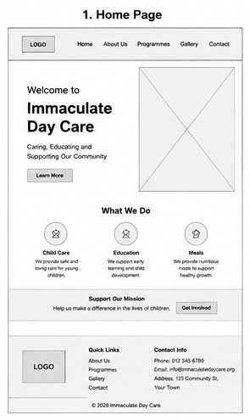
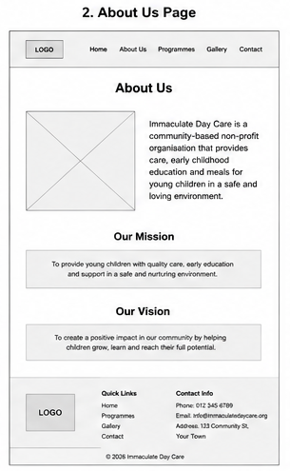
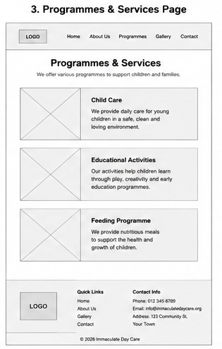
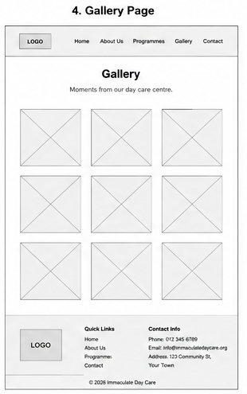
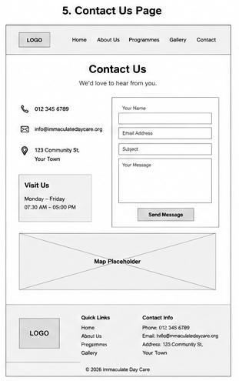
6. Technical Requirements
The website will be developed using standard web development technologies.
Proposed Technologies
- HTML – to create the structure and content of the website.
- CSS – to control the layout, colours, fonts and overall appearance.
- JavaScript – to add interactive features where necessary.
Hosting and Domain:
The website will require:
- A suitable domain name, such as a name based on Immaculate Day Care.
- Web hosting to make the website available online.
- An SSL certificate to provide a secure HTTPS connection.
The final hosting provider and domain will be selected based on cost, reliability and suitability for the organisation.

7. Timeline and Milestones
The project will be completed according to the subject's submission dates.
Stage | Activity | Realistic Timeframe
1 | Organisation research and project proposal | Week 1
2 | Gather website requirements and content | Weeks 2–3
3 | Plan website structure and navigation | Week 4
4 | Create low-fidelity wireframes | Week 5
5 | Develop the website structure using HTML | Weeks 6–7
6 | Apply styling and branding using CSS | Weeks 7–8
7 | Add interactive functionality using JavaScript | Weeks 8–9
8 | Test the website on different screen sizes | Week 10
9 | Correct errors and improve usability | Week 11
10 | Finalise the website and prepare submission | Week 12

8. Budget
The following is a proposed estimated budget for developing and maintaining the website:
Item | Estimated Cost
Domain registration | R250 per year
Web hosting | R1,200 per year
SSL certificate | R0 – R500 per year
Website development | R4,000
Website testing and optimisation | R1,000
Maintenance and updates | R1,500 per year
Estimated first-year total | R7,950 – R8,450

9. References
Everything used to reference information in this document is stated in the Immaculate Day Care Reference Document found in the Research folder.

